Personalized Habit Tracker

(AI-Powered Adaptive Habit Coach)

User Flow (end-to-end) diagram

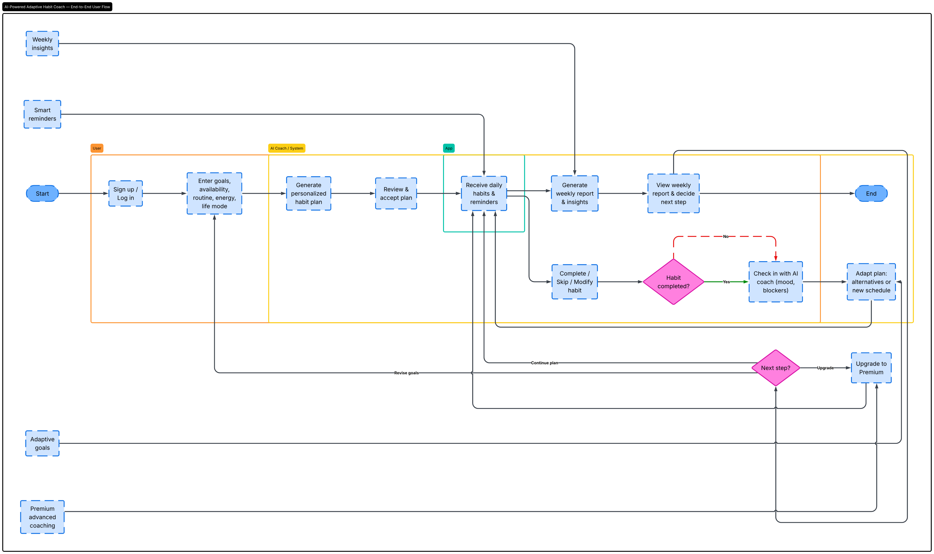

System Architecture (6 Layered):

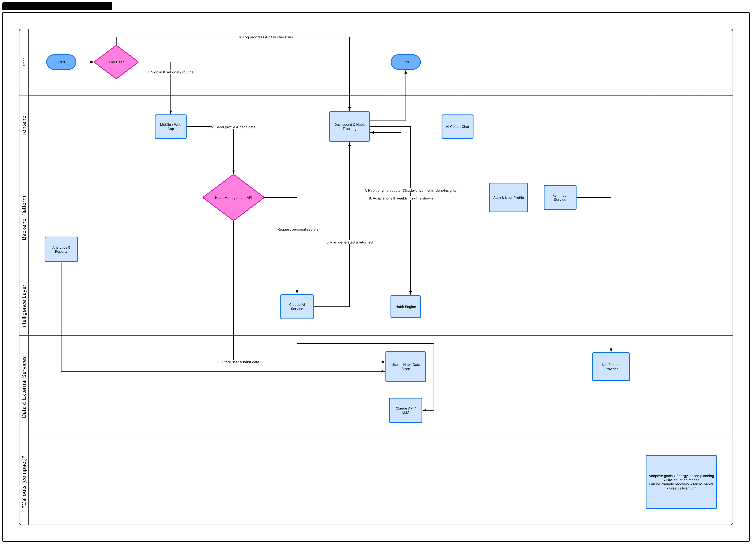

System Architecture (4 Layered):

